EXP NO 1: Configuration of Network Devices using Packet Tracer (Hub, Switch, Ethernet, Broadcast).

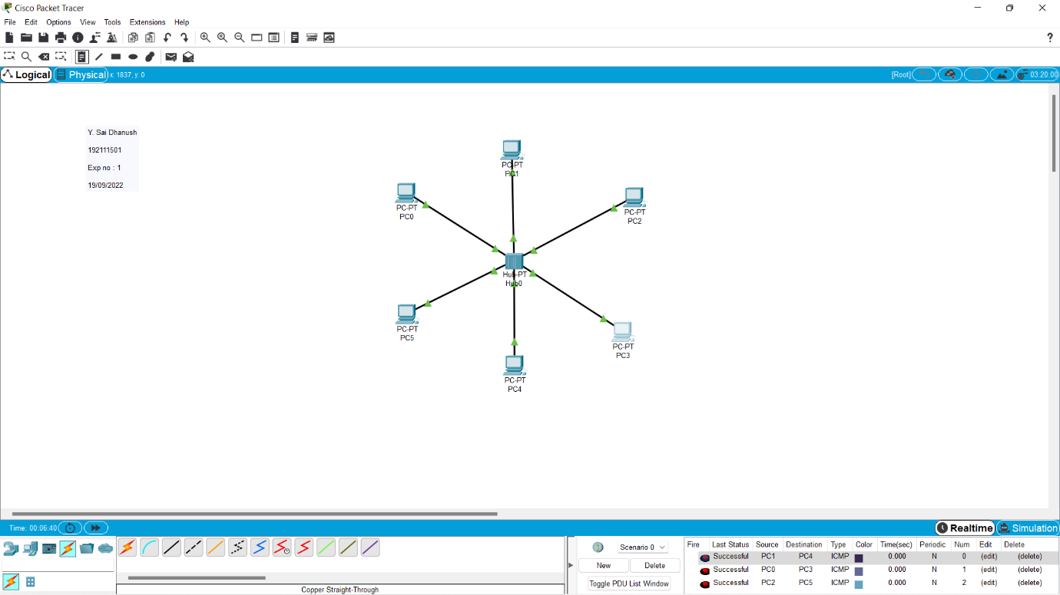

EXP NO 2 : Configuration of Topologies using Packet Tracer (Star, Mesh, Bus,).

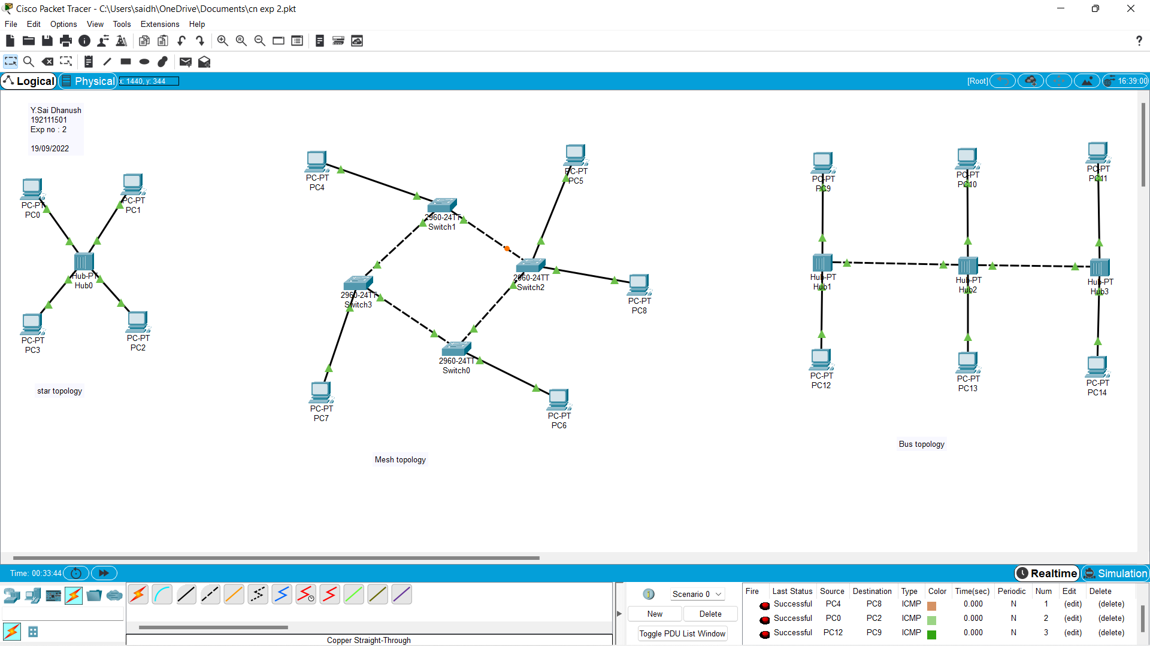

EXP NO 3 : Configuration of Topologies using Packet Tracer (Tree, Ring, Hybrid).

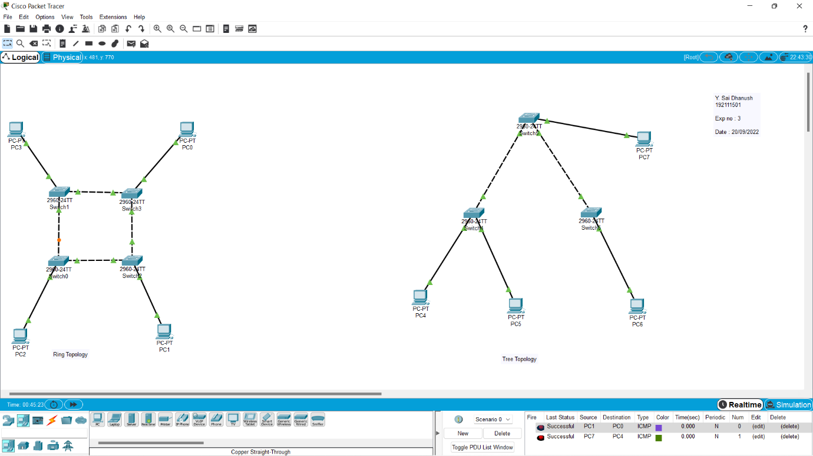

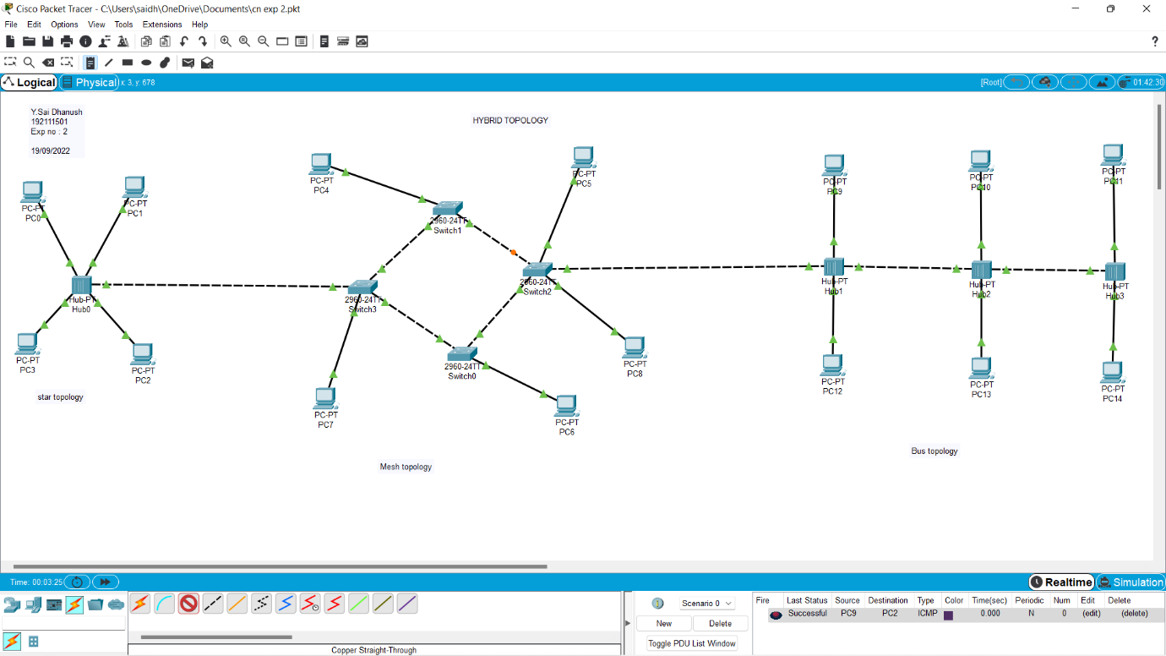

EXP NO 4 : Data Link Layer Traffic Simulation using Packet Tracer Analysis of CSMA/CD& CSMA/CA.

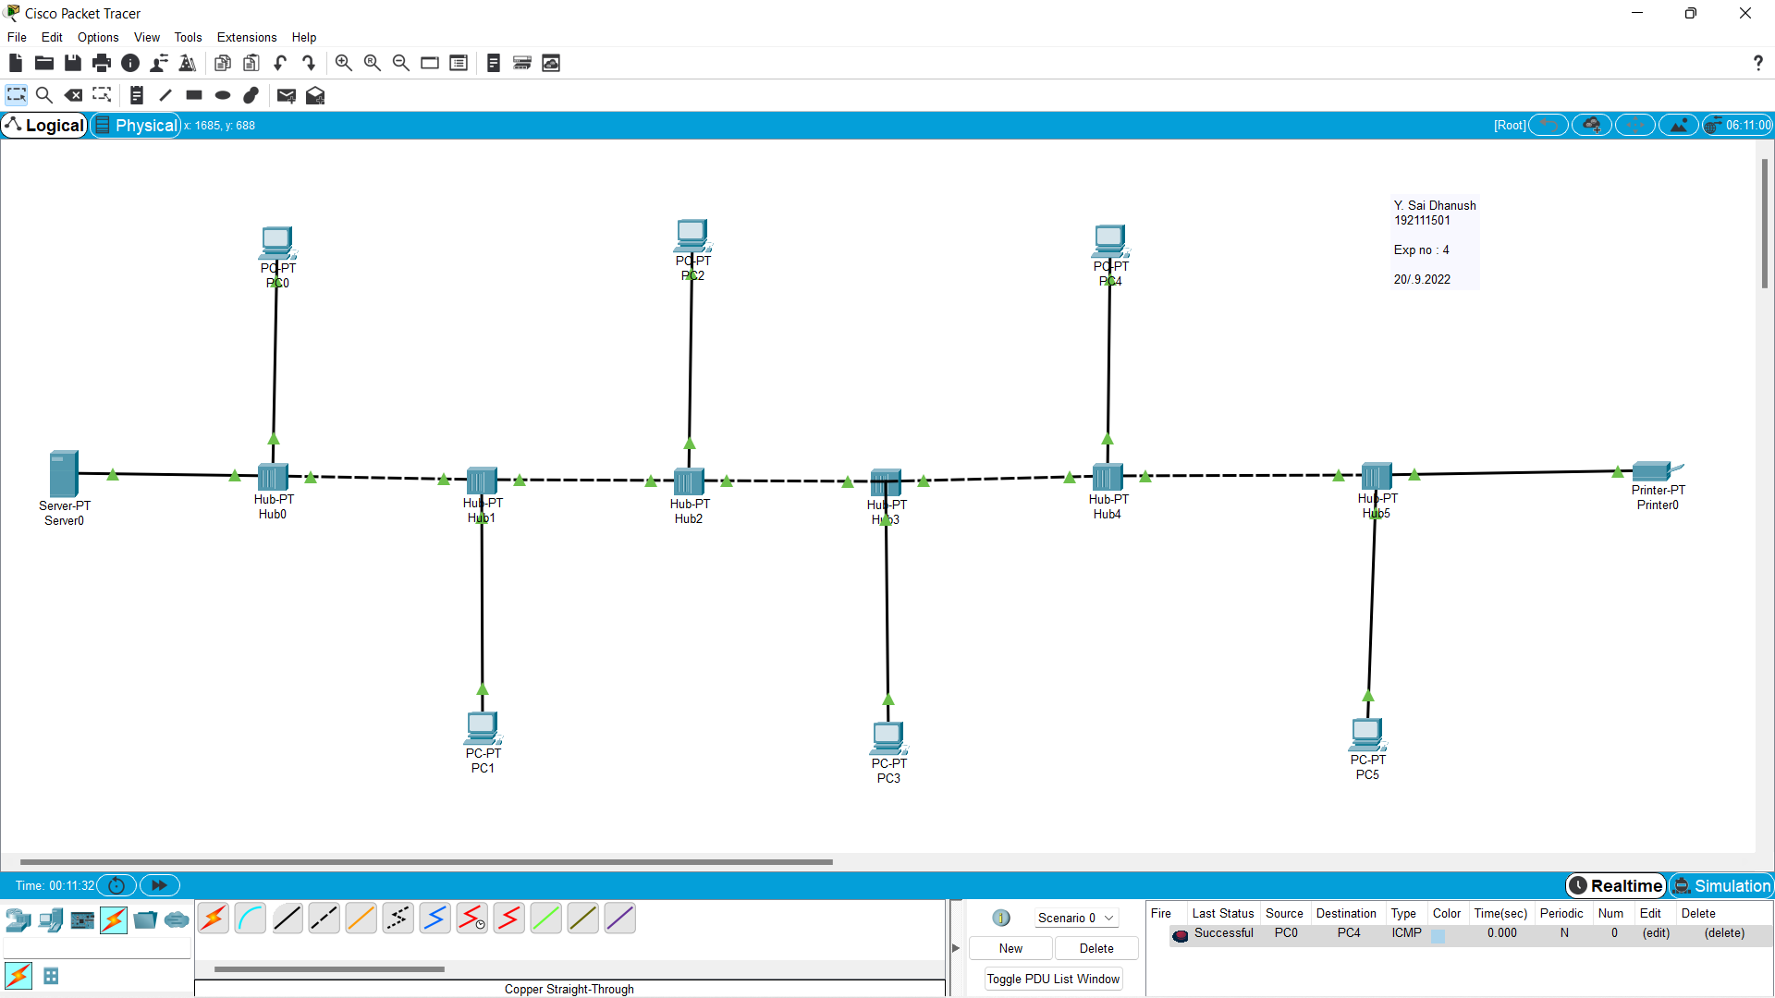

EXP NO 5 : Data Link Layer Traffic Simulation using Packet Tracer Analysis of ARP .

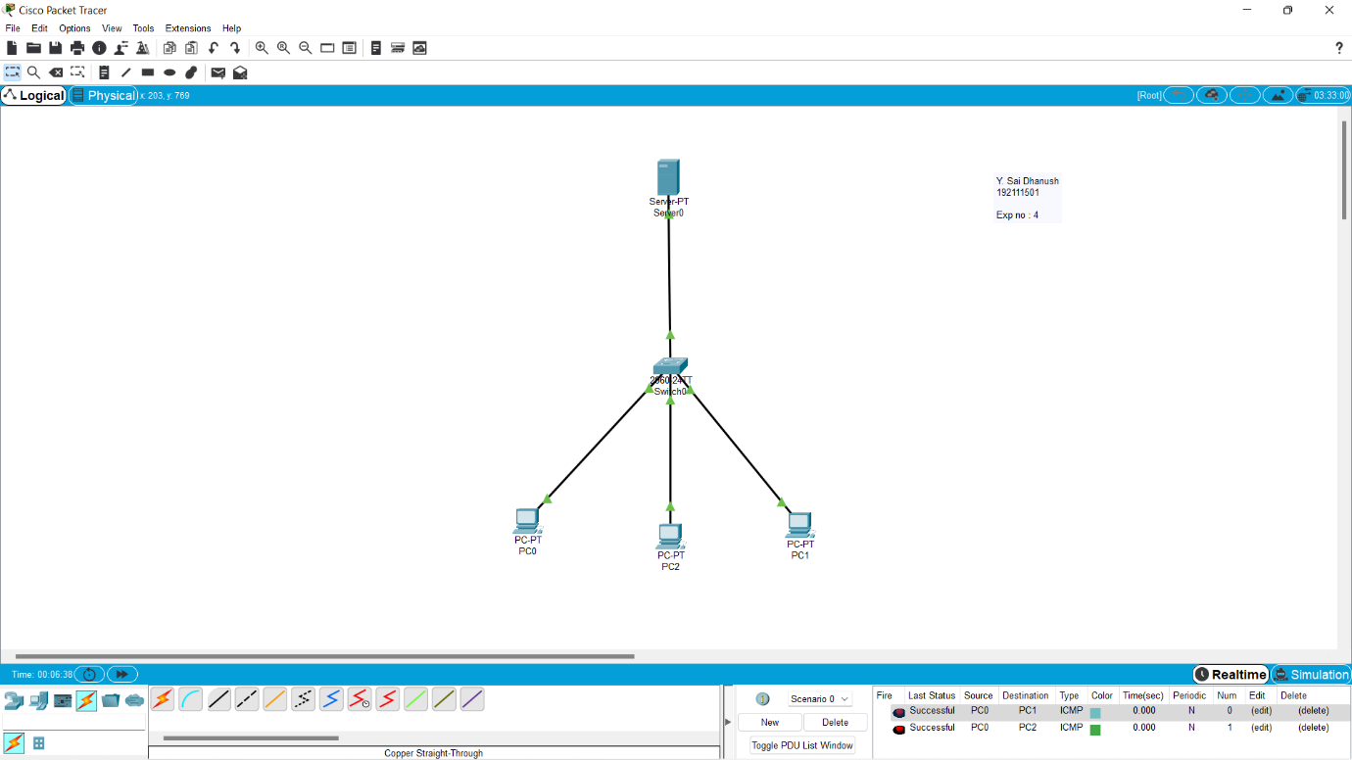

EXP NO 6 : Static Routing using Packet Tracer.

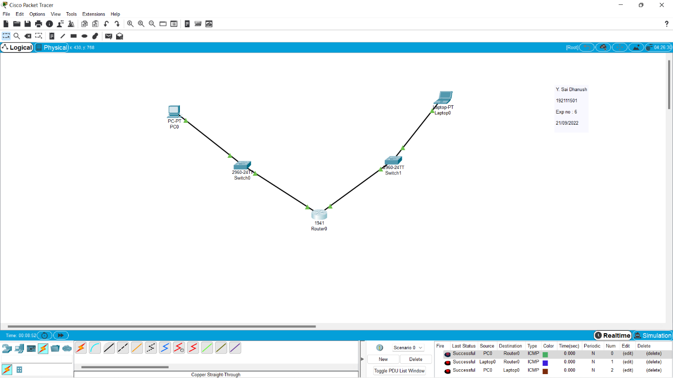

EXP NO 7 : Dynamic Routing using Packet Tracer ( OSPF).

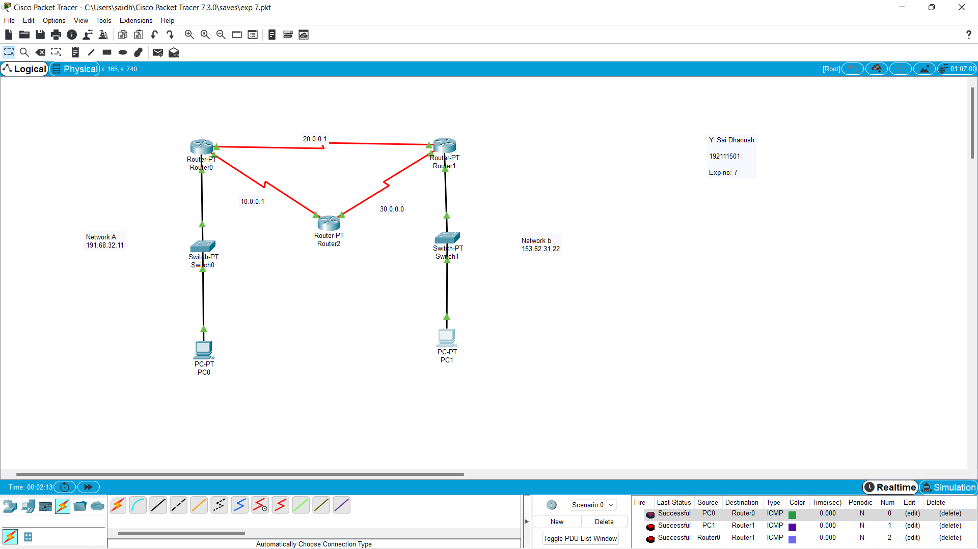

EXP NO 8 : Subnetting – Class C Addressing.

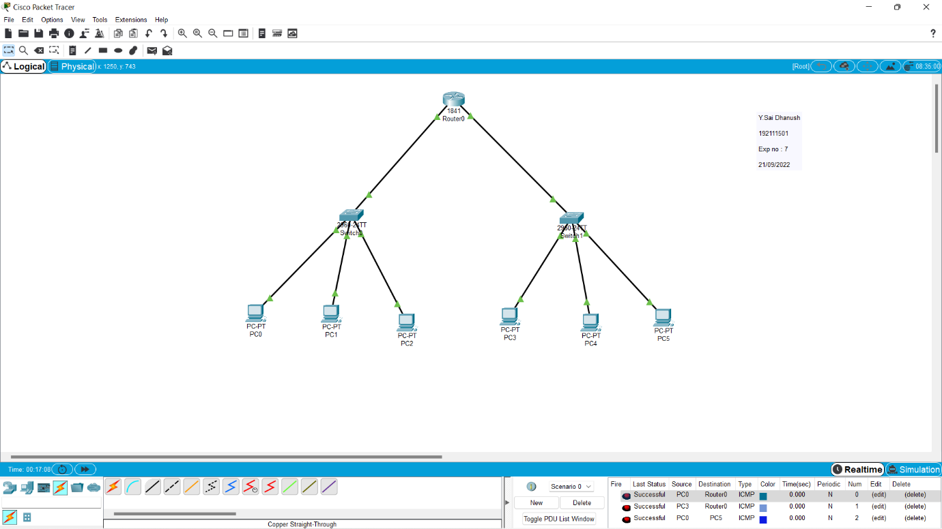

EXP NO 9 : Functionalities of TCP, UDP.

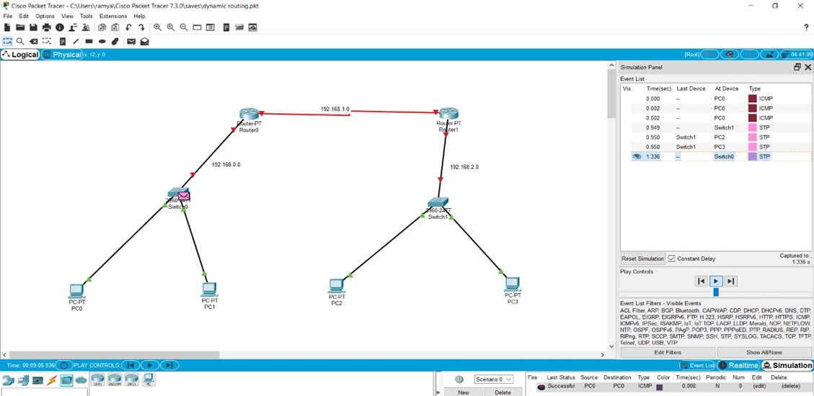

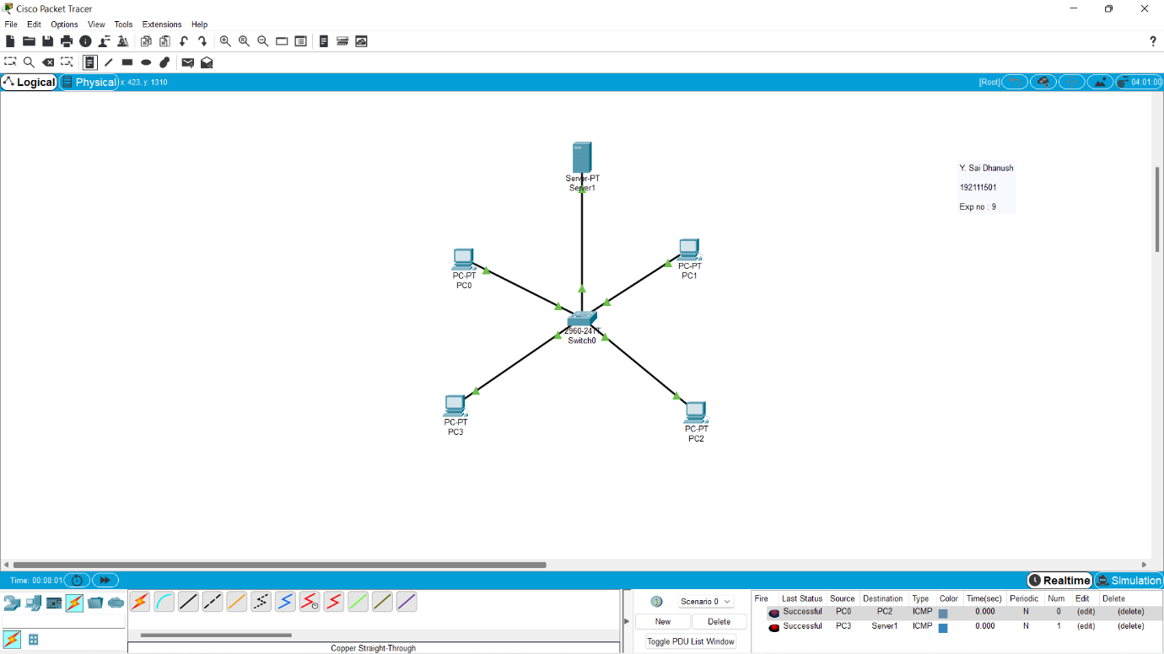

EXP NO 10 : TCP, UDP Exploration Solution.

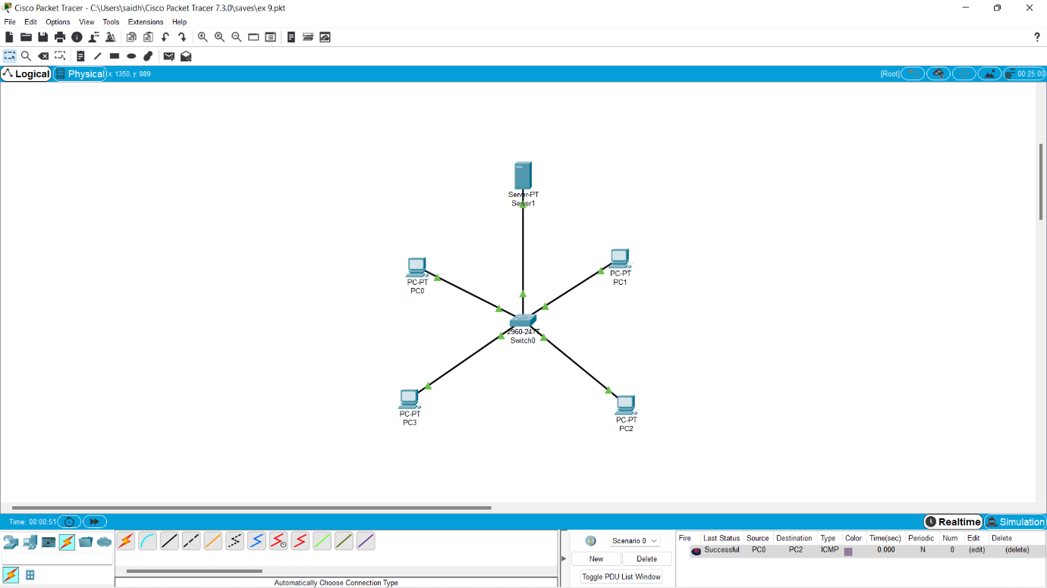

EXP NO 11 : IOT Based Smart Home Using Cisco Packet Tracer.

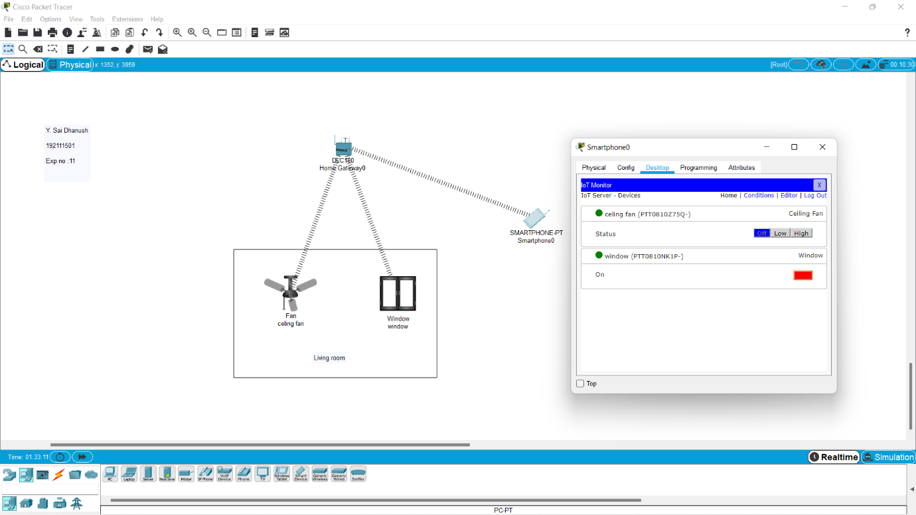

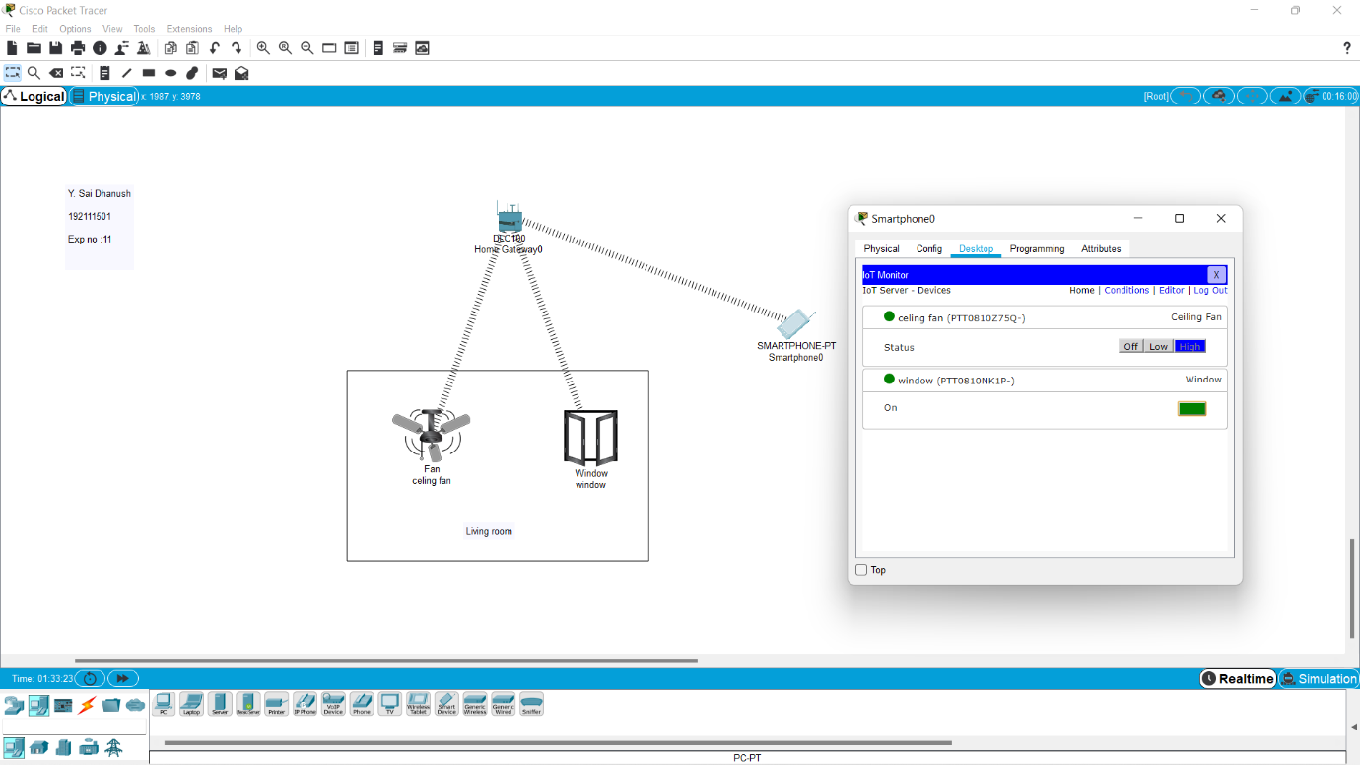

EXP NO 12 : Smart Garden in Cisco Packet Tracer

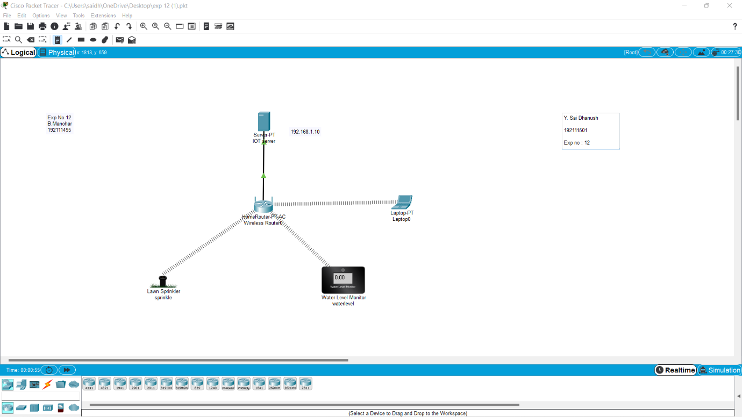

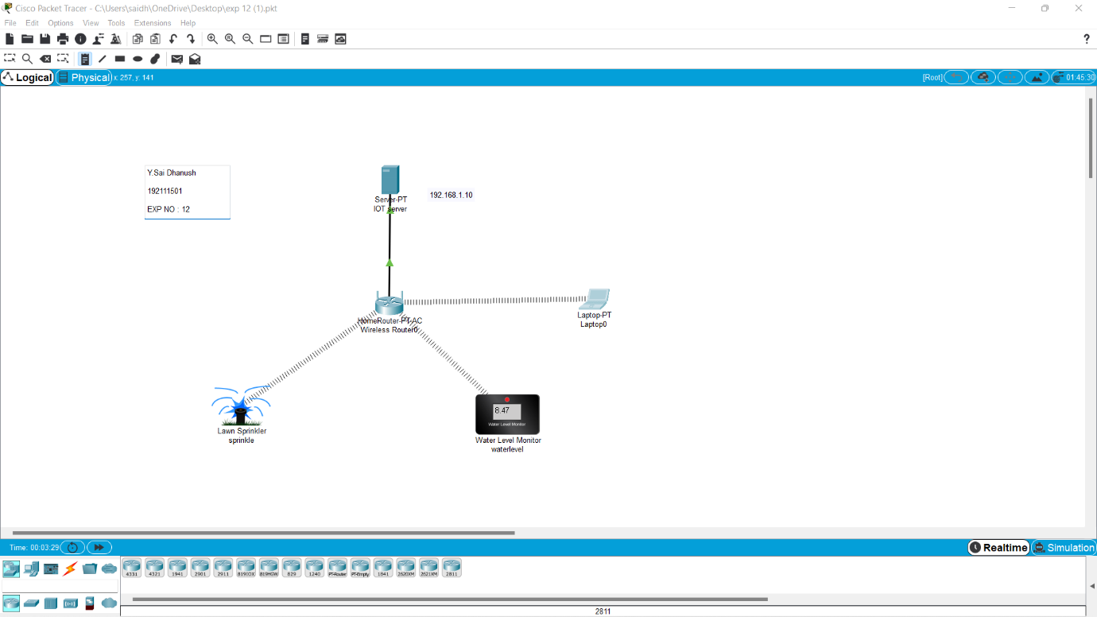

EXP NO 13 : IOT Devices in Networking Using Cisco Packet Tracer

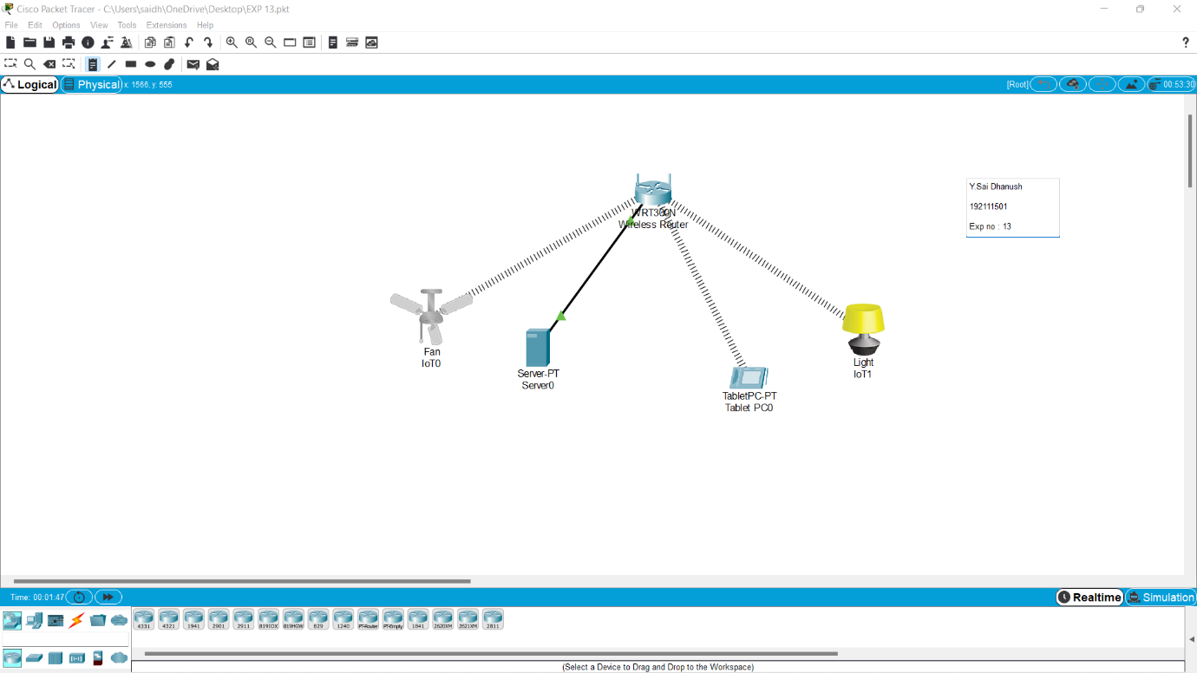

.EXP NO 14 : Simulating X,Y,Z Company Network Design

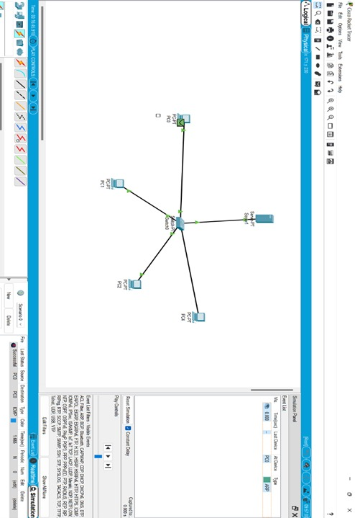

EXP NO !5 : Make Computer Lab in Cisco Packet Tracer

